**TECHNICAL DATA SHEET**

**NANOBUILD s.r.o.,** Na Folimance 2155/15, 12000 Praha, Czechia

Correspondence address, laboratory: Mayerova 1067, 341 01 Horažďovice

Company identification number: 60647965

e-mail: nanobuildinfo@gmail.com, tel: +420 602305209

**Product name: Surface treatment material 2D-2R**

**Product description:**

The material consists of a suspension of multi-layer graphene in a dispersion medium, consisting of non-flammable and durable polymers and filled with a complex compound of highly refractory materials. It is produced by a patented method of exfoliating graphite in liquid media and does not pose a risk to human health or the environment.

**Technical parameters:**

|  |  |  |
| --- | --- | --- |
| **Parameter** | **Unit** | **Value** |
| **Form** | - | Viscous suspension |
| **Average lateral particle size** | (µm) | 6 |
| **Color** | - | Grey to black |
| **Time of use of the material since its production** | - | up to 24 months |
| **Storage temperature** | (°C) | from -5 to +450 °C |

**Use:** This material is designed to protect devices and objects from electromagnetic radiation, as well as to absorb and attenuate electromagnetic waves in the range from 3 to 110 GHz. It absorbs up to 98 % of electromagnetic radiation at a thickness of 2 to 3 mm.

This material is capable of operating at temperatures up to 8000 °C and at object speeds of up to 500 m/s and can be used to protect electrical appliances, computer systems, storage media, navigation systems from electronic warfare, as well as to cover various objects to reduce the reflection of electromagnetic radiation.

The stability of the coefficients S11, S21, S12 and S22 in this range indicates reliable material characteristics.

This coating can be adapted to the operating conditions of the equipment in agreement with the customer.

The performance characteristics are shown in Figures 1 and 2

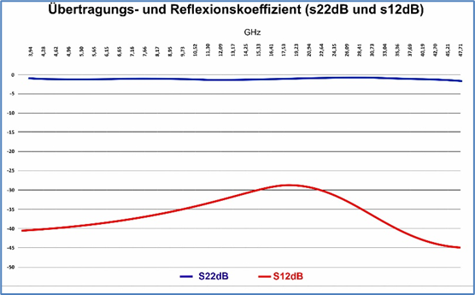

Figure 1

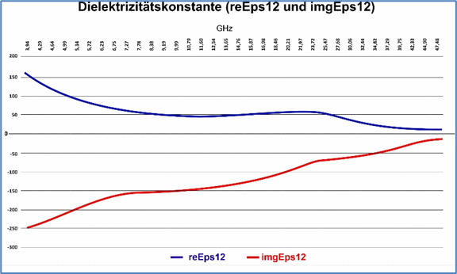

Figure 2